# Oracle备份服务器安装

## 服务器信息

### 1.1、服务器信息

|  |  |  |  |  |
| --- | --- | --- | --- | --- |
| 设备 | 型号 | 内存 | cpu | 硬盘 |
| oracle服务器 | 浪潮 NF5270M4 | Intel(R) Xeon(R) CPU E5-2609 v3 @ 1.90GHz | 32G | 1.81T |

### 1.2、服务器系统和oracle信息

|  |  |  |  |  |  |  |
| --- | --- | --- | --- | --- | --- | --- |
| 设备 | 系统 | 内存 | 硬盘 | oracle版本 | IP | 备注 |
| oracle服务器 | rhel6.5 | 32 | 1.81T | linuxamd64_12102_database | 172.16.28.25 |  |

## 系统配置

### 2.1、安装oracle必须的安装rpm包

|  |
| --- |
| yum -y install binutils compat-libstdc++-33 elfutils-libelf \  elfutils-libelf-devel elfutils-libelf-devel-static gcc gcc-c++ glibc glibc-common \  glibc-devel kernel-headers ksh libaio libaio-devel libgcc libgomp libstdc++ libstdc++-devel \  make numactl-devel sysstat unixODBC unixODBC-devel pdksh compat-libcap1 |

|  |
| --- |
| 执行结果：  [root@orcl yum.repos.d]# yum -y install binutils compat-libstdc++-33 elfutils-libelf \  > elfutils-libelf-devel elfutils-libelf-devel-static gcc gcc-c++ glibc glibc-common \  > glibc-devel kernel-headers ksh libaio libaio-devel libgcc libgomp libstdc++ libstdc++-devel \  > make numactl-devel sysstat unixODBC unixODBC-devel pdksh compat-libcap1  Loaded plugins: product-id, refresh-packagekit, security, subscription-manager  This system is not registered to Red Hat Subscription Management. You can use subscription-manager to register.  local | 3.9 kB 00:00 ...  local/primary_db | 3.1 MB 00:00 ...  Setting up Install Process  Package binutils-2.20.51.0.2-5.36.el6.x86_64 already installed and latest version  Package elfutils-libelf-0.152-1.el6.x86_64 already installed and latest version  No package elfutils-libelf-devel-static available.  Package glibc-2.12-1.132.el6.x86_64 already installed and latest version  Package glibc-common-2.12-1.132.el6.x86_64 already installed and latest version  Package glibc-devel-2.12-1.132.el6.x86_64 already installed and latest version  Package kernel-headers-2.6.32-431.el6.x86_64 already installed and latest version  Package libaio-0.3.107-10.el6.x86_64 already installed and latest version  Package libgcc-4.4.7-4.el6.x86_64 already installed and latest version  Package libgomp-4.4.7-4.el6.x86_64 already installed and latest version  Package libstdc++-4.4.7-4.el6.x86_64 already installed and latest version  Package 1:make-3.81-20.el6.x86_64 already installed and latest version  Package sysstat-9.0.4-22.el6.x86_64 already installed and latest version  No package pdksh available.  Resolving Dependencies  --> Running transaction check  ---> Package compat-libcap1.x86_64 0:1.10-1 will be installed  ---> Package compat-libstdc++-33.x86_64 0:3.2.3-69.el6 will be installed  ---> Package elfutils-libelf-devel.x86_64 0:0.152-1.el6 will be installed  ---> Package gcc.x86_64 0:4.4.7-4.el6 will be installed  --> Processing Dependency: cpp = 4.4.7-4.el6 for package: gcc-4.4.7-4.el6.x86_64  --> Processing Dependency: cloog-ppl >= 0.15 for package: gcc-4.4.7-4.el6.x86_64  ---> Package gcc-c++.x86_64 0:4.4.7-4.el6 will be installed  --> Processing Dependency: libmpfr.so.1()(64bit) for package: gcc-c++-4.4.7-4.el6.x86_64  ---> Package ksh.x86_64 0:20120801-10.el6 will be installed  ---> Package libaio-devel.x86_64 0:0.3.107-10.el6 will be installed  ---> Package libstdc++-devel.x86_64 0:4.4.7-4.el6 will be installed  ---> Package numactl-devel.x86_64 0:2.0.7-8.el6 will be installed  ---> Package unixODBC.x86_64 0:2.2.14-12.el6_3 will be installed  ---> Package unixODBC-devel.x86_64 0:2.2.14-12.el6_3 will be installed  --> Running transaction check  ---> Package cloog-ppl.x86_64 0:0.15.7-1.2.el6 will be installed  --> Processing Dependency: libppl_c.so.2()(64bit) for package: cloog-ppl-0.15.7-1.2.el6.x86_64  --> Processing Dependency: libppl.so.7()(64bit) for package: cloog-ppl-0.15.7-1.2.el6.x86_64  ---> Package cpp.x86_64 0:4.4.7-4.el6 will be installed  ---> Package mpfr.x86_64 0:2.4.1-6.el6 will be installed  --> Running transaction check  ---> Package ppl.x86_64 0:0.10.2-11.el6 will be installed  --> Finished Dependency Resolution  Dependencies Resolved  ================================================================================  Package Arch Version Repository Size  ================================================================================  Installing:  compat-libcap1 x86_64 1.10-1 local 17 k  compat-libstdc++-33 x86_64 3.2.3-69.el6 local 183 k  elfutils-libelf-devel x86_64 0.152-1.el6 local 31 k  gcc x86_64 4.4.7-4.el6 local 10 M  gcc-c++ x86_64 4.4.7-4.el6 local 4.7 M  ksh x86_64 20120801-10.el6 local 756 k  libaio-devel x86_64 0.3.107-10.el6 local 13 k  libstdc++-devel x86_64 4.4.7-4.el6 local 1.6 M  numactl-devel x86_64 2.0.7-8.el6 local 35 k  unixODBC x86_64 2.2.14-12.el6_3 local 378 k  unixODBC-devel x86_64 2.2.14-12.el6_3 local 53 k  Installing for dependencies:  cloog-ppl x86_64 0.15.7-1.2.el6 local 93 k  cpp x86_64 4.4.7-4.el6 local 3.7 M  mpfr x86_64 2.4.1-6.el6 local 156 k  ppl x86_64 0.10.2-11.el6 local 1.3 M  Transaction Summary  ================================================================================  Install 15 Package(s)  Total download size: 23 M  Installed size: 57 M  Downloading Packages:  --------------------------------------------------------------------------------  Total 116 MB/s | 23 MB 00:00  Running rpm_check_debug  Running Transaction Test  Transaction Test Succeeded  Running Transaction  Installing : mpfr-2.4.1-6.el6.x86_64 1/15  Installing : cpp-4.4.7-4.el6.x86_64 2/15  Installing : ppl-0.10.2-11.el6.x86_64 3/15  Installing : cloog-ppl-0.15.7-1.2.el6.x86_64 4/15  Installing : gcc-4.4.7-4.el6.x86_64 5/15  Installing : unixODBC-2.2.14-12.el6_3.x86_64 6/15  Installing : libstdc++-devel-4.4.7-4.el6.x86_64 7/15  Installing : gcc-c++-4.4.7-4.el6.x86_64 8/15  Installing : unixODBC-devel-2.2.14-12.el6_3.x86_64 9/15  Installing : ksh-20120801-10.el6.x86_64 10/15  Installing : elfutils-libelf-devel-0.152-1.el6.x86_64 11/15  Installing : compat-libstdc++-33-3.2.3-69.el6.x86_64 12/15  Installing : libaio-devel-0.3.107-10.el6.x86_64 13/15  Installing : numactl-devel-2.0.7-8.el6.x86_64 14/15  Installing : compat-libcap1-1.10-1.x86_64 15/15  local/productid | 1.7 kB 00:00 ...  Verifying : compat-libcap1-1.10-1.x86_64 1/15  Verifying : libstdc++-devel-4.4.7-4.el6.x86_64 2/15  Verifying : unixODBC-devel-2.2.14-12.el6_3.x86_64 3/15  Verifying : numactl-devel-2.0.7-8.el6.x86_64 4/15  Verifying : cpp-4.4.7-4.el6.x86_64 5/15  Verifying : libaio-devel-0.3.107-10.el6.x86_64 6/15  Verifying : mpfr-2.4.1-6.el6.x86_64 7/15  Verifying : compat-libstdc++-33-3.2.3-69.el6.x86_64 8/15  Verifying : unixODBC-2.2.14-12.el6_3.x86_64 9/15  Verifying : elfutils-libelf-devel-0.152-1.el6.x86_64 10/15  Verifying : gcc-4.4.7-4.el6.x86_64 11/15  Verifying : ksh-20120801-10.el6.x86_64 12/15  Verifying : gcc-c++-4.4.7-4.el6.x86_64 13/15  Verifying : ppl-0.10.2-11.el6.x86_64 14/15  Verifying : cloog-ppl-0.15.7-1.2.el6.x86_64 15/15  Installed:  compat-libcap1.x86_64 0:1.10-1  compat-libstdc++-33.x86_64 0:3.2.3-69.el6  elfutils-libelf-devel.x86_64 0:0.152-1.el6  gcc.x86_64 0:4.4.7-4.el6  gcc-c++.x86_64 0:4.4.7-4.el6  ksh.x86_64 0:20120801-10.el6  libaio-devel.x86_64 0:0.3.107-10.el6  libstdc++-devel.x86_64 0:4.4.7-4.el6  numactl-devel.x86_64 0:2.0.7-8.el6  unixODBC.x86_64 0:2.2.14-12.el6_3  unixODBC-devel.x86_64 0:2.2.14-12.el6_3  Dependency Installed:  cloog-ppl.x86_64 0:0.15.7-1.2.el6 cpp.x86_64 0:4.4.7-4.el6  mpfr.x86_64 0:2.4.1-6.el6 ppl.x86_64 0:0.10.2-11.el6  Complete!  [root@orcl yum.repos.d]# |

### 2.2、创建oracle安装用户

|  |
| --- |
| groupadd dba  groupadd oinstall  useradd -g oinstall -G dba oracle  id oracle |

|  |
| --- |
| 执行结果：  [root@orcl yum.repos.d]# groupadd dba  [root@orcl yum.repos.d]#  [root@orcl yum.repos.d]# groupadd oinstall  [root@orcl yum.repos.d]#  [root@orcl yum.repos.d]# useradd -g oinstall -G dba oracle  [root@orcl yum.repos.d]#  [root@orcl yum.repos.d]# id oracle  uid=500(oracle) gid=501(oinstall) groups=501(oinstall),500(dba)  [root@orcl yum.repos.d]# |

### 2.3、创建oracle安装目录

|  |
| --- |
| mkdir -p /home/oracle/app/oracle  chown -R oracle:oinstall /home/oracle/app/  chmod -R 775 /home/oracle/app/oracle |

|  |
| --- |
| 执行结果：  [root@orcl yum.repos.d]# mkdir -p /home/oracle/app/oracle  [root@orcl yum.repos.d]#  [root@orcl yum.repos.d]# chown -R oracle:oinstall /home/oracle/app/oracle  [root@orcl yum.repos.d]#  [root@orcl yum.repos.d]# chmod -R 775 /home/oracle/app/oracle  [root@orcl yum.repos.d]# |

### 2.4、关闭SELinux

#### 2.4.1、临时关闭

在root用户下执行：setenforce 0

#### 2.4.2、永久关闭

|  |
| --- |
| 使用root修改/etc/selinux/config，将SELINUX=enforcing修改成SELINUX=disabled |

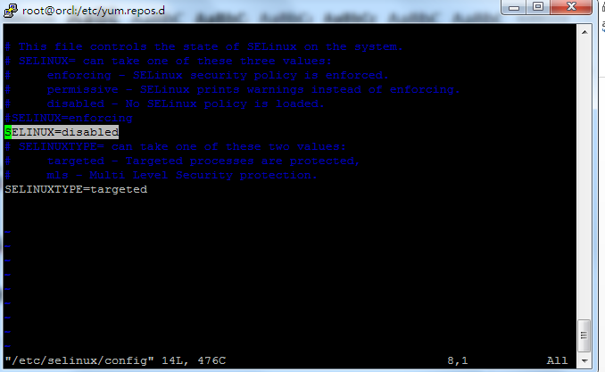

### 2.5、修改系统内核参数

|  |
| --- |
| 在/etc/sysctl.conf文件中添加如下参数：  #oracle's configure  fs.aio-max-nr = 1048576  fs.file-max = 6815744  kernel.sem = 250 32000 100 128  kernel.shmmni = 4096  kernel.shmall = 1073741824  kernel.shmmax = 4398046511104  net.core.rmem_default = 262144  net.core.rmem_max = 4194304  net.core.wmem_default = 262144  net.core.wmem_max = 1048576  net.ipv4.ip_local_port_range = 9000 65500  kernel.panic_on_oops = 1 |

最后使用sysctl –p命令使配置生效

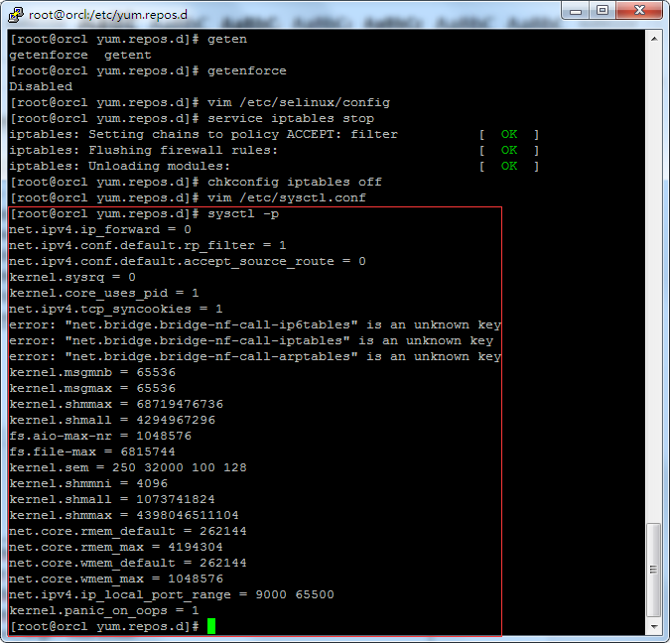

### 2.6、修改用户限制

|  |
| --- |
| 在/etc/security/limits.conf添加如下参数  oracle soft nproc 2047  oracle hard nproc 16384  oracle soft nofile 1024  oracle hard nofile 65536  oracle soft stack 10240  oracle hard stack 10240 |

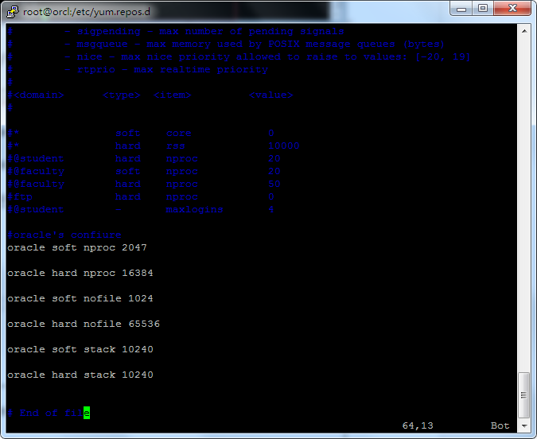

|  |
| --- |
| 在/etc/security/limits.d/90-nproc.conf添加如下内容  #Oracle setting  * - nproc 16384 |

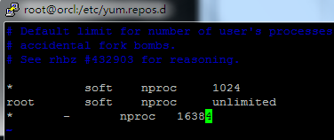

### 2.7、修改oracle用户参数

使用su – oracle 切换到oracle用户下

|  |
| --- |
| 然后修改/home/oracle/Bash_profile,添加如下内容：  TMP=/tmp; export TMP  TMPDIR=$TMP; export TMPDIR  ORACLE_BASE=/home/oracle/app/oracle; export ORACLE_BASE  ORACLE_HOME=$ORACLE_BASE/product/12.1.0/db_1; export ORACLE_HOME  ORACLE_TERM=xterm; export ORACLE_TERM  PATH=/usr/sbin:$PATH; export PATH  PATH=$ORACLE_HOME/bin:$PATH; export PATH  LD_LIBRARY_PATH=$ORACLE_HOME/lib:/lib:/usr/lib; export LD_LIBRARY_PATH  CLASSPATH=$ORACLE_HOME/JRE:$ORACLE_HOME/jlib:$ORACLE_HOME/rdbms/jlib; export CLASSPATH  if [ $USER = "oracle" ]; then  if [ $SHELL = "/bin/ksh" ]; then  ulimit -p 16384  ulimit -n 65536  else  ulimit -u 16384 -n 65536  fi  fi |

### 2.8、安装vnc图形界面

|  |
| --- |
| 使用yum –y install vnc vnc-server命令安装vnc图形界面软件  [root@orcl yum.repos.d]# yum -y install vnc vnc-server  Loaded plugins: product-id, refresh-packagekit, security, subscription-manager  This system is not registered to Red Hat Subscription Management. You can use subscription-manager to register.  Setting up Install Process  Resolving Dependencies  --> Running transaction check  ---> Package tigervnc.x86_64 0:1.1.0-5.el6_4.1 will be installed  ---> Package tigervnc-server.x86_64 0:1.1.0-5.el6_4.1 will be installed  --> Finished Dependency Resolution  Dependencies Resolved  ================================================================================  Package Arch Version Repository Size  ================================================================================  Installing:  tigervnc x86_64 1.1.0-5.el6_4.1 local 257 k  tigervnc-server x86_64 1.1.0-5.el6_4.1 local 1.1 M  Transaction Summary  ================================================================================  Install 2 Package(s)  Total download size: 1.4 M  Installed size: 3.5 M  Downloading Packages:  --------------------------------------------------------------------------------  Total 99 MB/s | 1.4 MB 00:00  Running rpm_check_debug  Running Transaction Test  Transaction Test Succeeded  Running Transaction  Installing : tigervnc-server-1.1.0-5.el6_4.1.x86_64 1/2  Installing : tigervnc-1.1.0-5.el6_4.1.x86_64 2/2  Verifying : tigervnc-1.1.0-5.el6_4.1.x86_64 1/2  Verifying : tigervnc-server-1.1.0-5.el6_4.1.x86_64 2/2  Installed:  tigervnc.x86_64 0:1.1.0-5.el6_4.1 tigervnc-server.x86_64 0:1.1.0-5.el6_4.1  Complete!  [root@orcl yum.repos.d]# |

|  |
| --- |
| 启动vnc：  [root@orcl yum.repos.d]# chkconfig vncserver on  [root@orcl yum.repos.d]# vncserver  You will require a password to access your desktops.  Password:  Verify:  xauth: creating new authority file /root/.Xauthority  xauth: (stdin):1: bad display name "orcl.com:1" in "add" command  New 'orcl.com:1 (root)' desktop is orcl.com:1  Creating default startup script /root/.vnc/xstartup  Starting applications specified in /root/.vnc/xstartup  Log file is /root/.vnc/orcl.com:1.log  [root@orcl yum.repos.d]# |

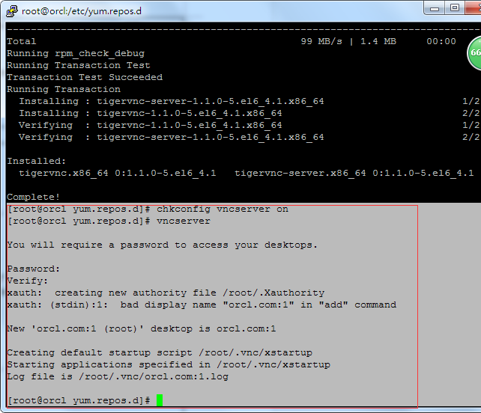

### 2.9、修改hosts配置

|  |
| --- |
| [root@orcl mnt]# hostname  orcl.com |

然后使用root修改/etc/hosts文件

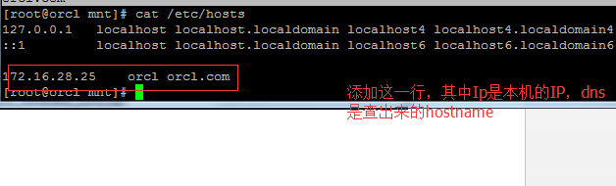

## 3、开始安装oracle软件

### 3.1、解压安装软件

|  |
| --- |
| unzip linuxamd64_12102_database_1of2.zip  unzip linuxamd64_12102_database_2of2.zip |

### 3.2、连接vnc界面开始安装

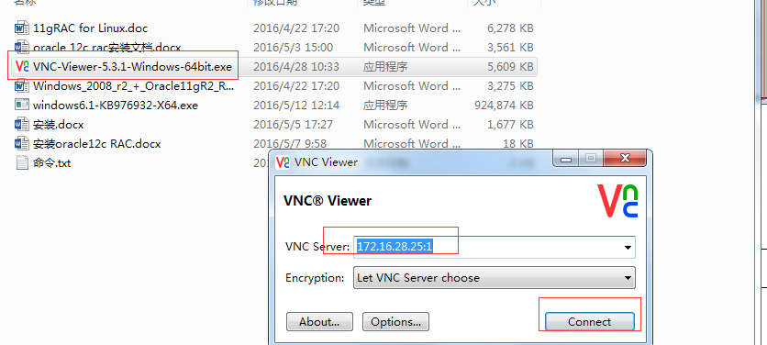

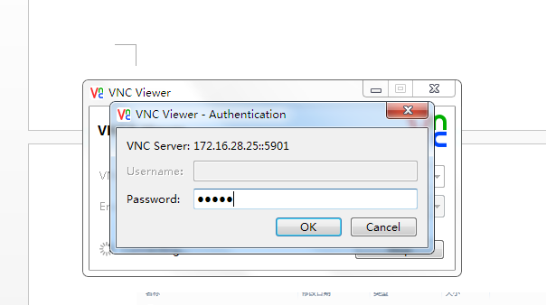

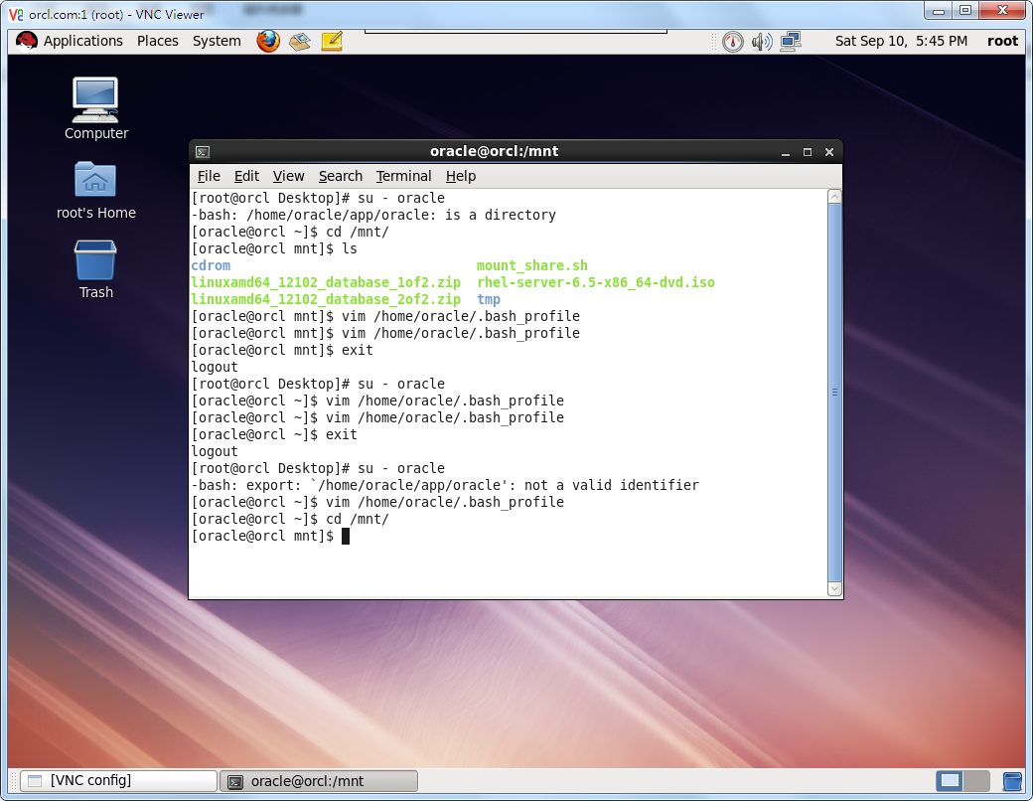

### 3.3、启动安装

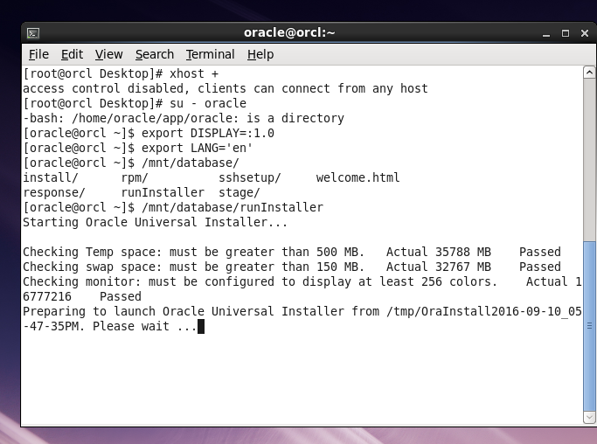

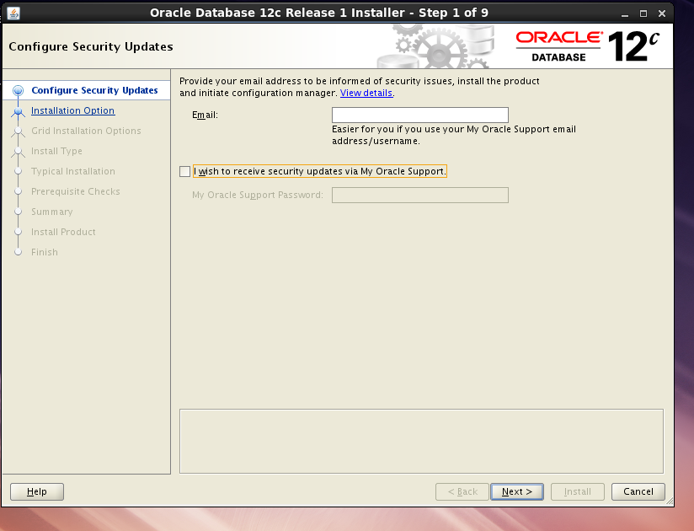

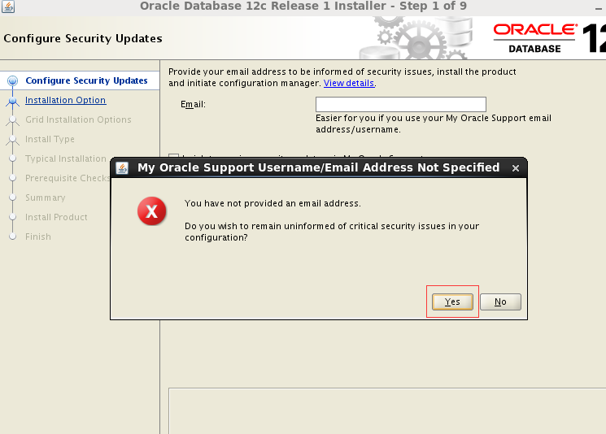

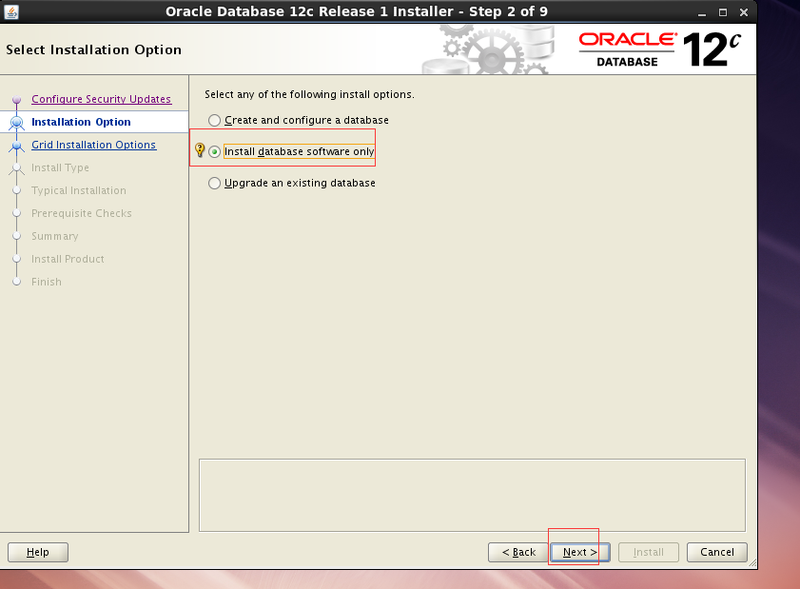

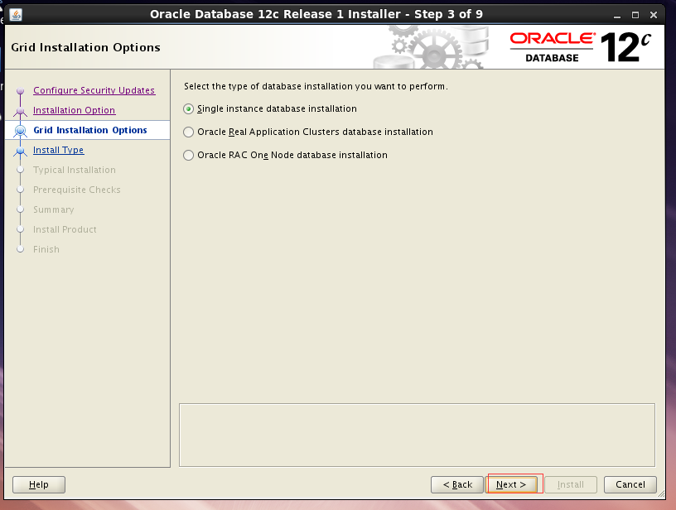

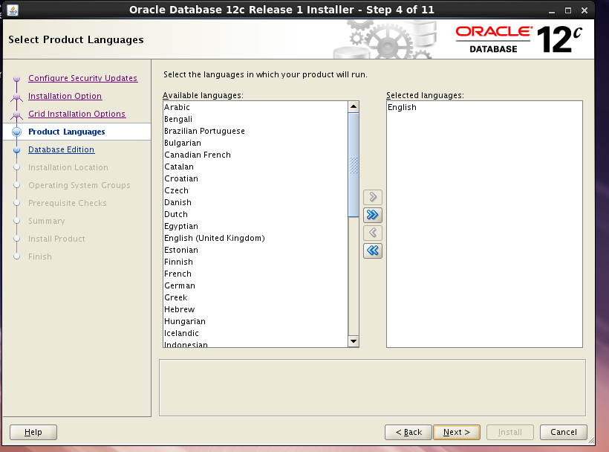

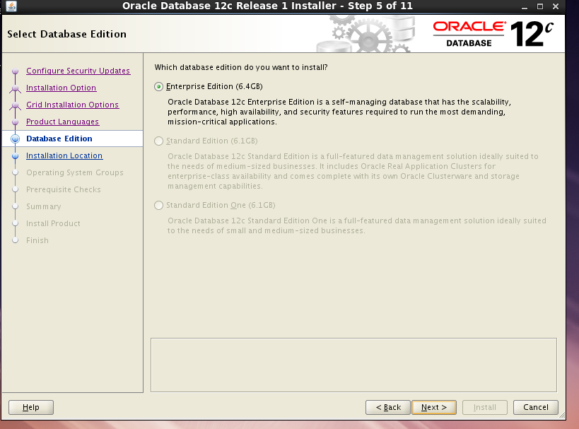

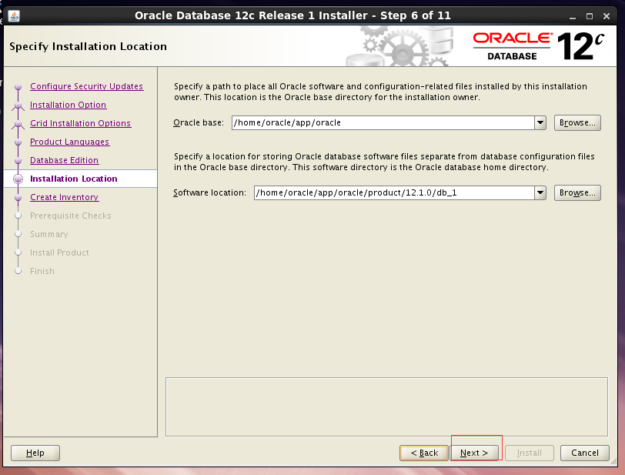

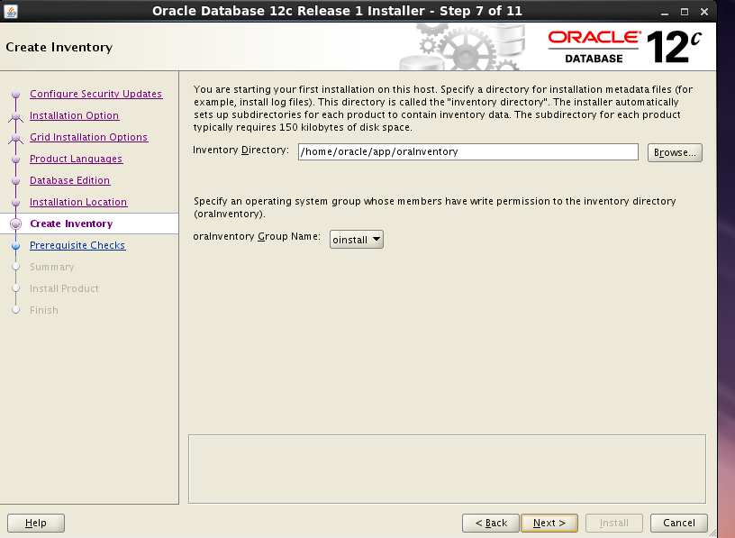

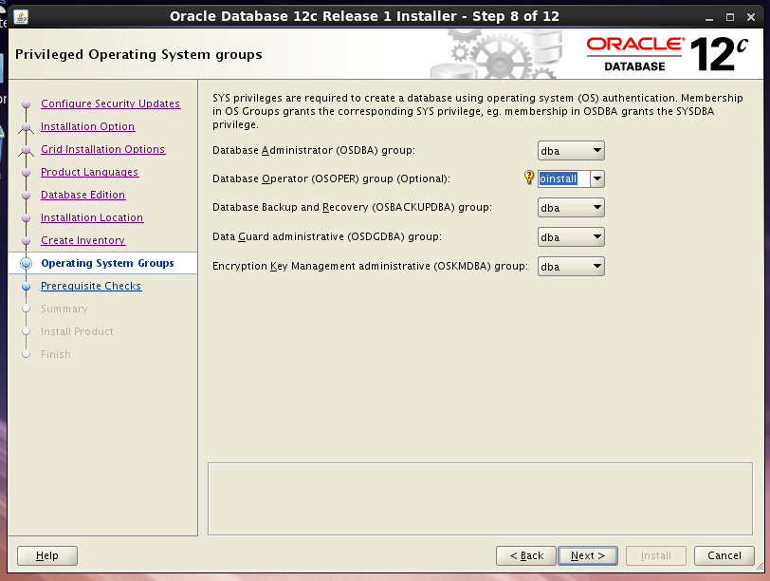

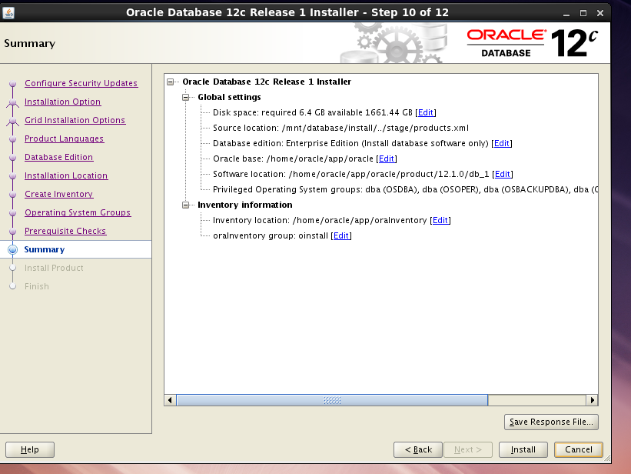

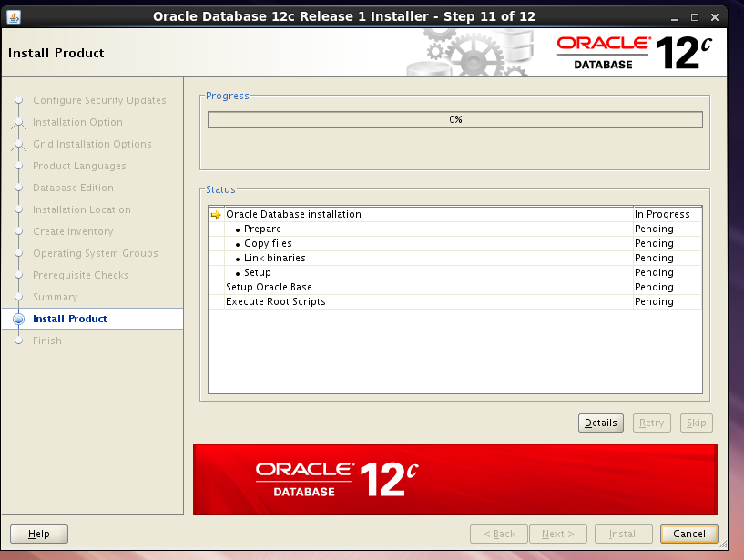

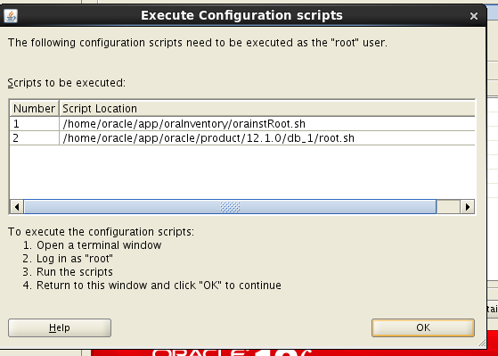

按照要求去执行脚本

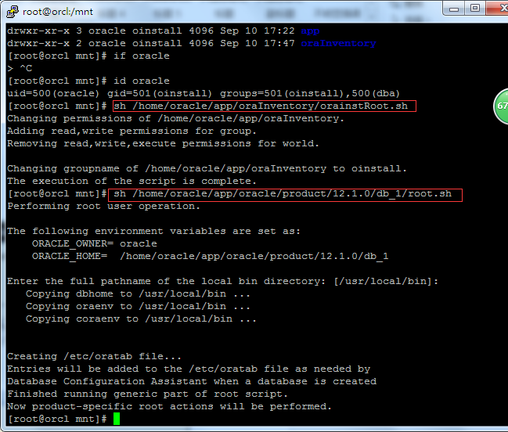

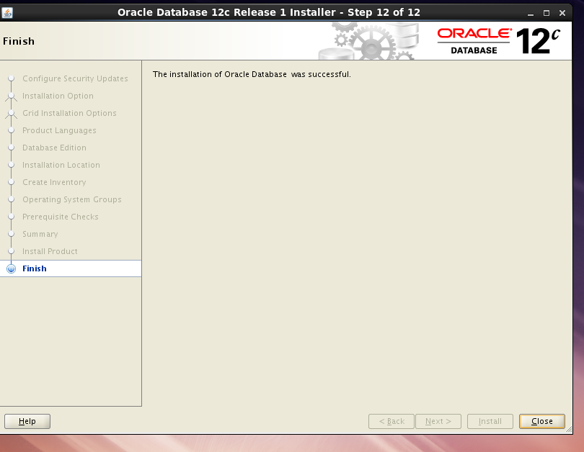

## 4、创建数据库

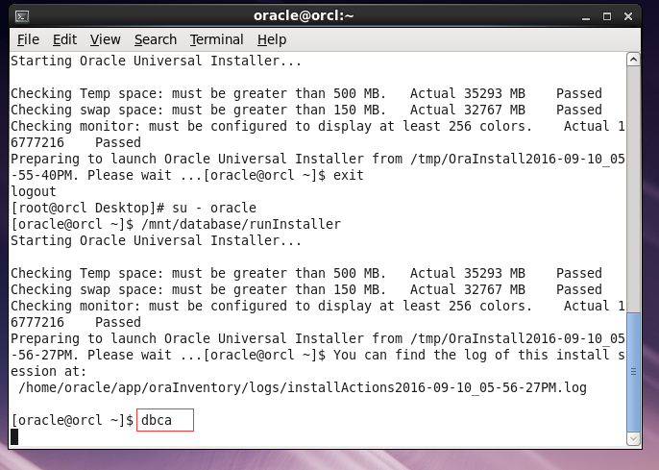

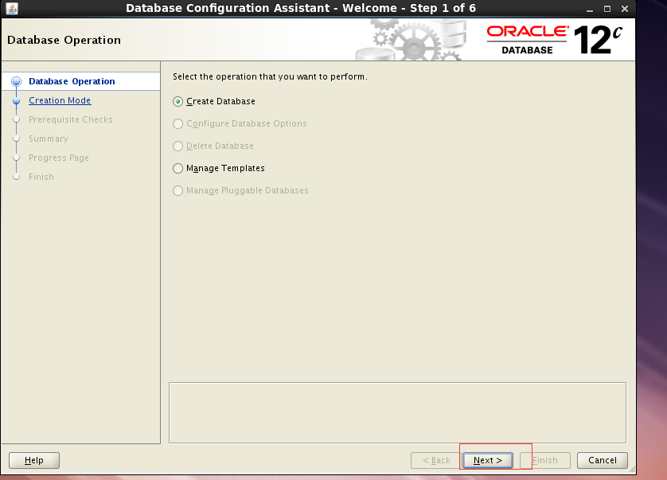

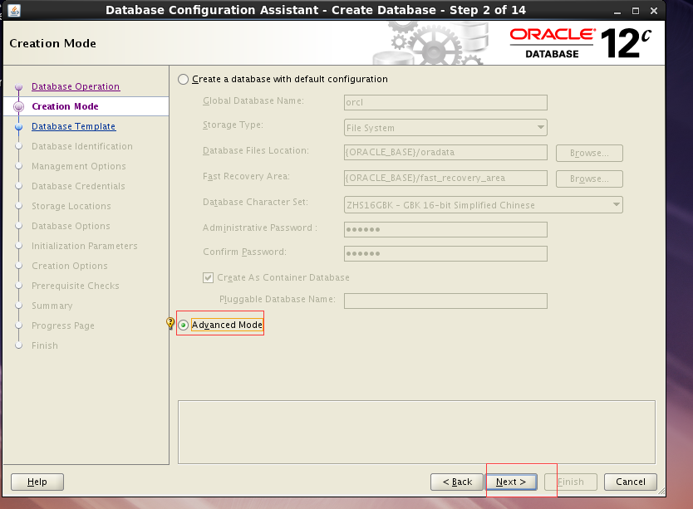

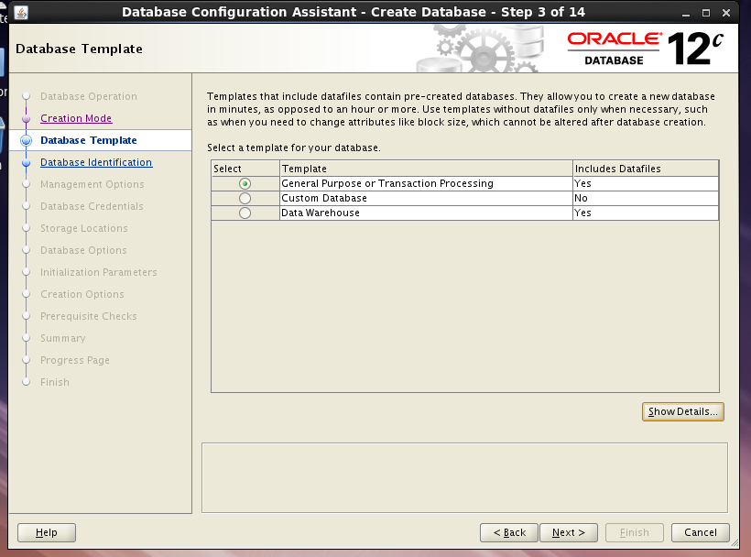

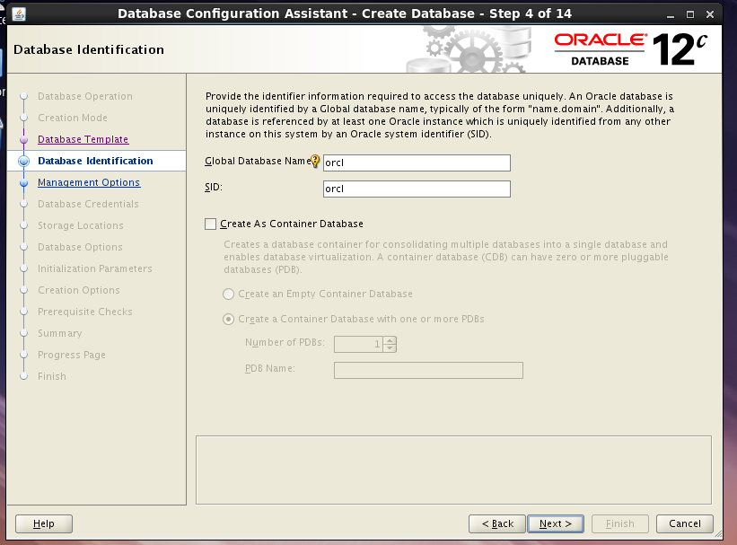

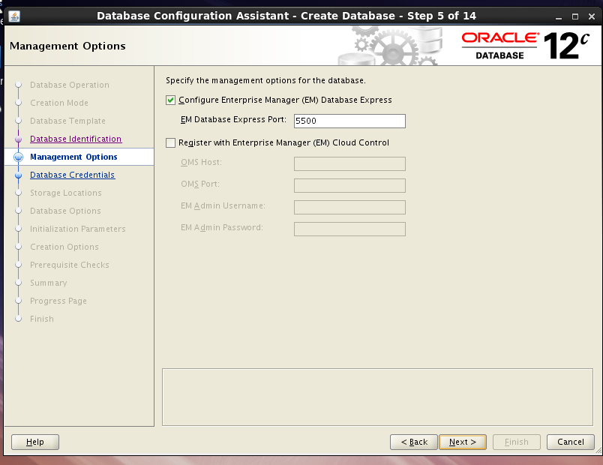

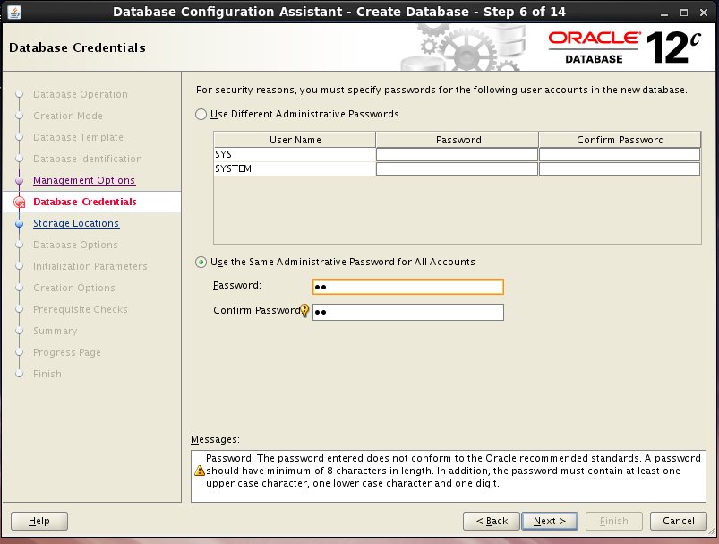

设置密码：aa

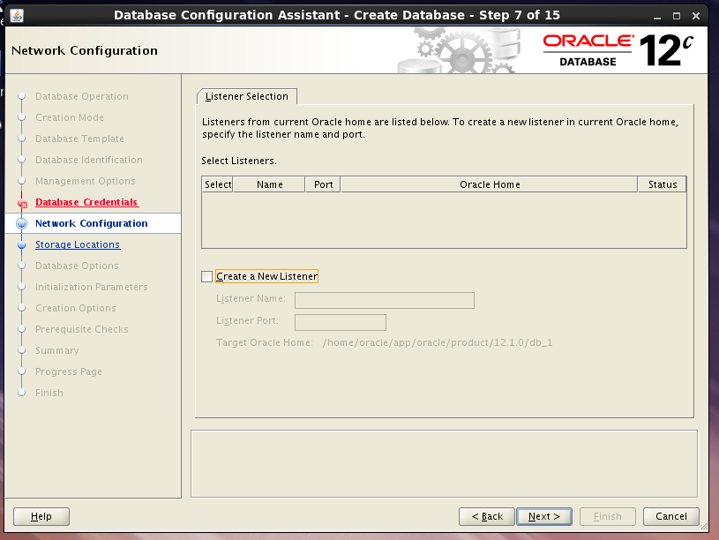

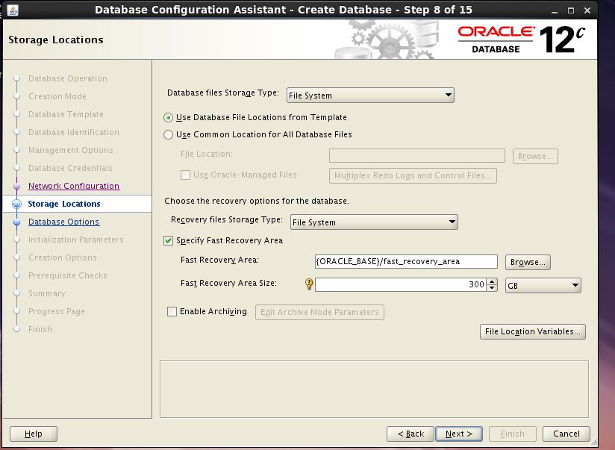

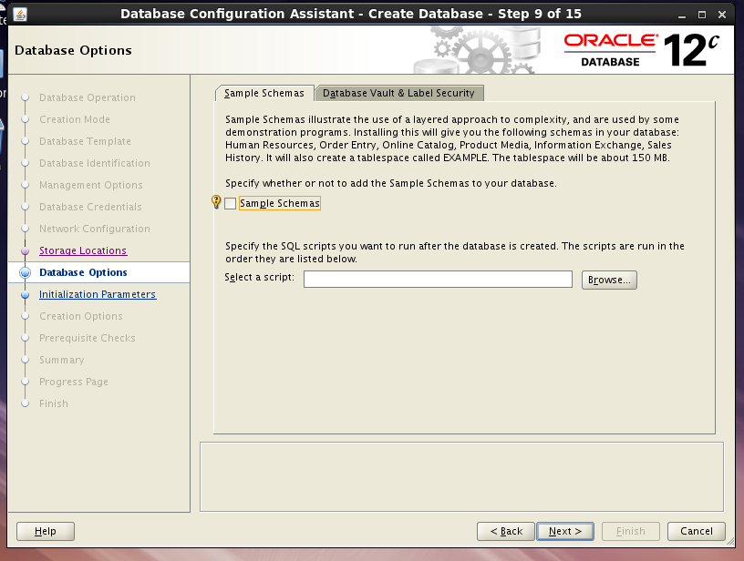

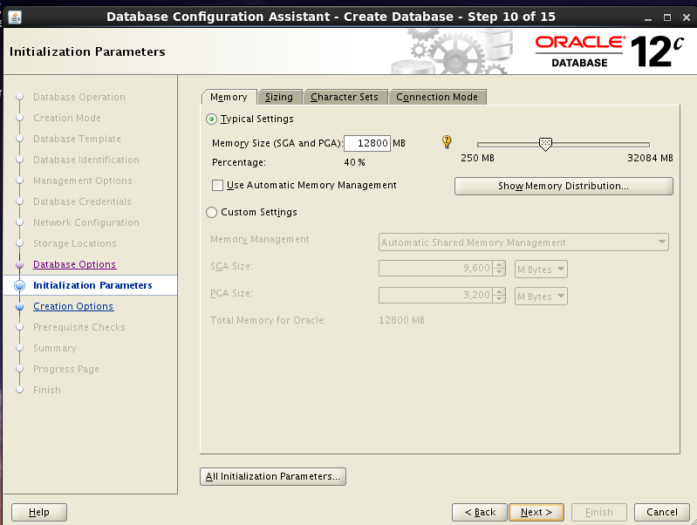

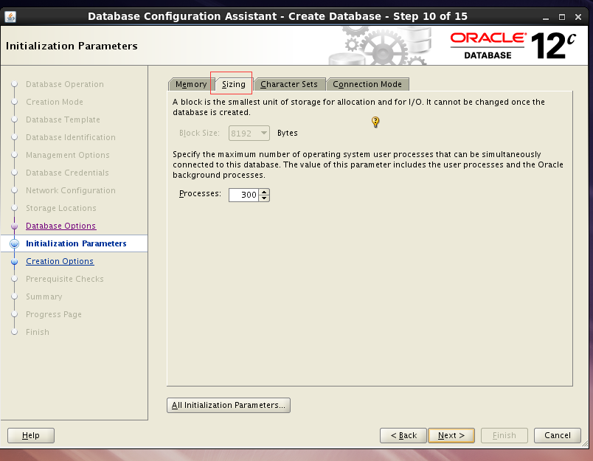

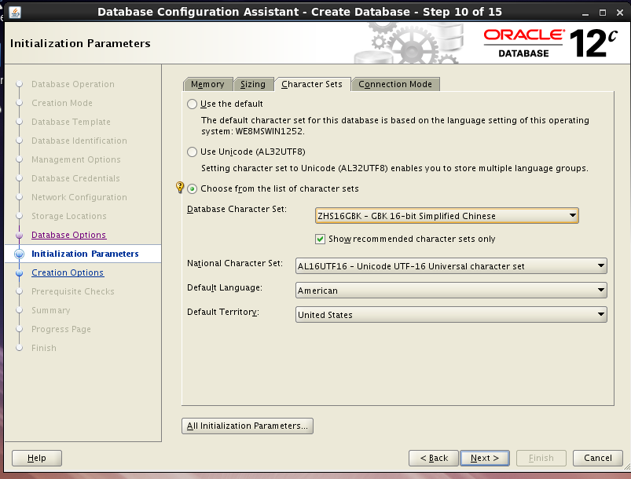

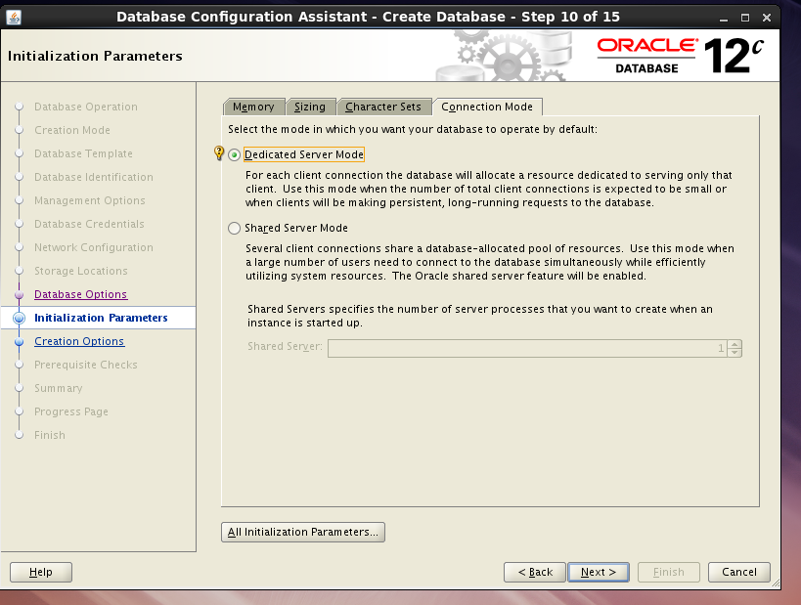

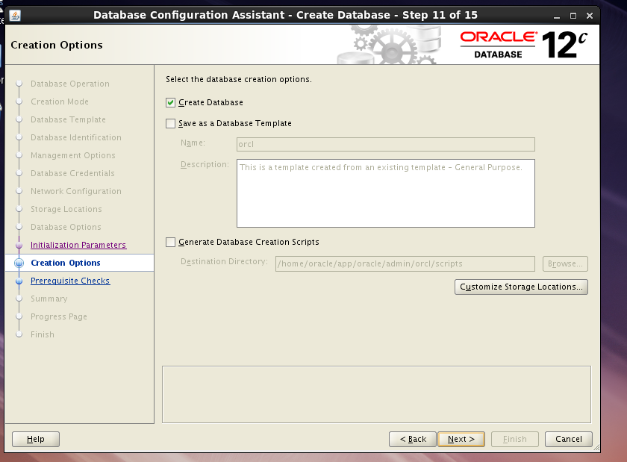

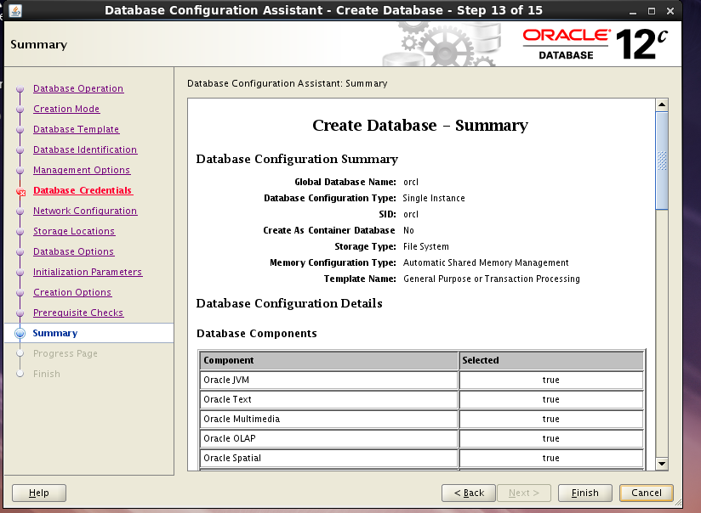

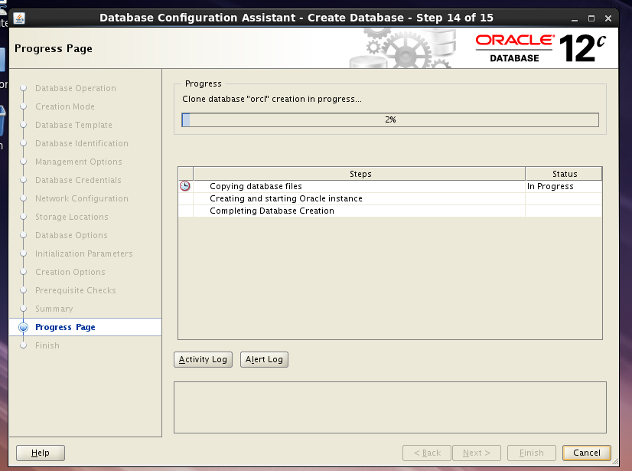

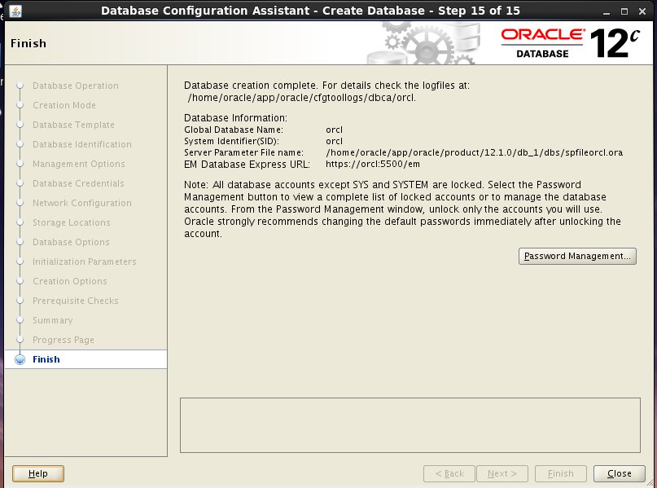

## 5、创建监听

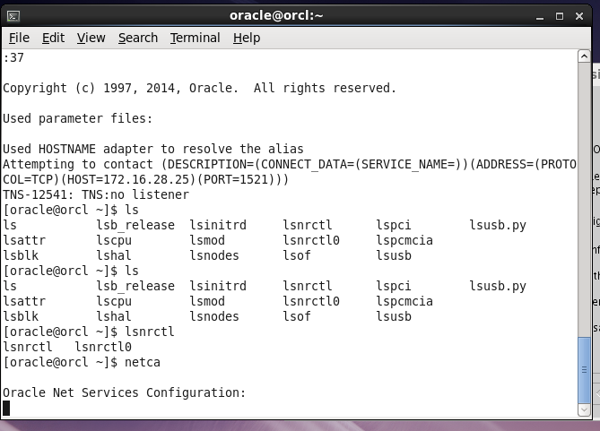

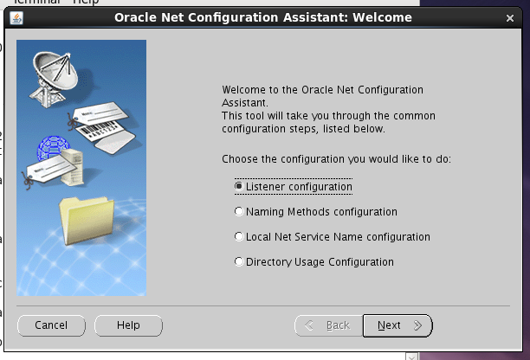

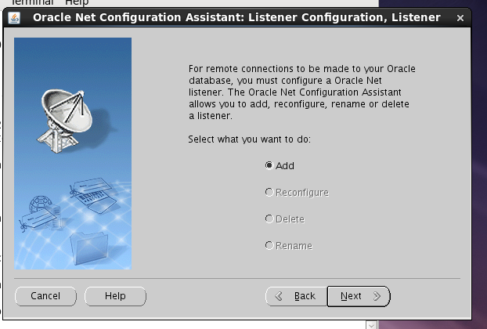

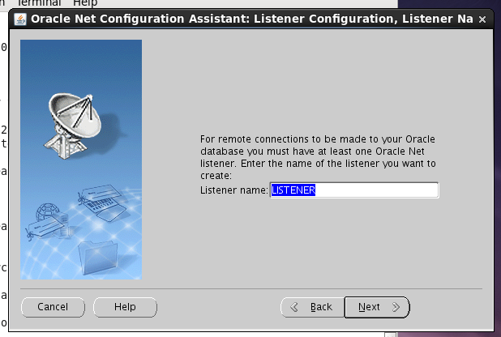

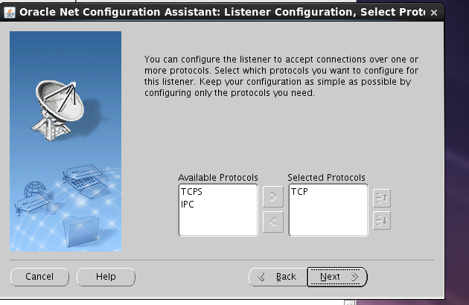

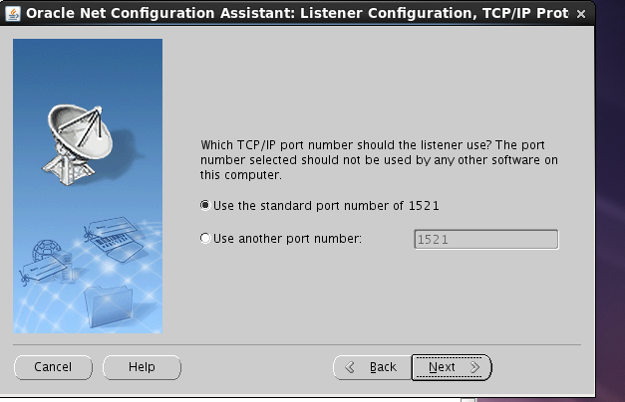

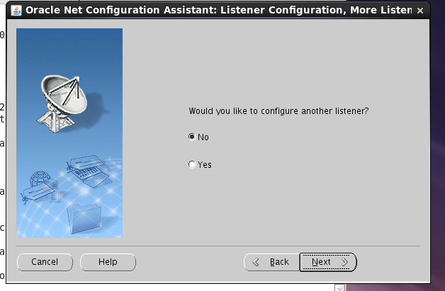

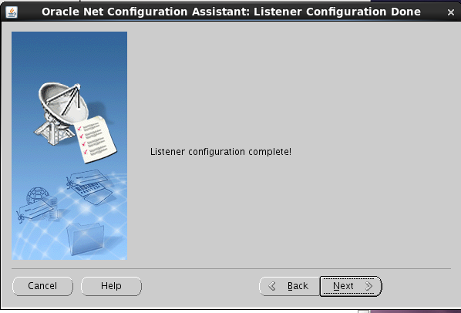

## 6、查看是否安装成功

### 6.1、tnsping orcl

